Ulva Assay

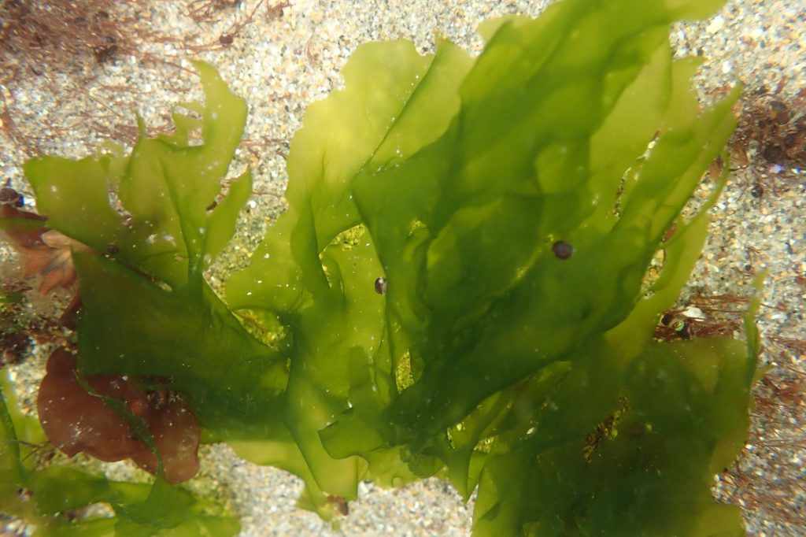

How to cite this work: Protocol: Ulva Assay (2021). Tennenbaum Marine Observatories Network, MarineGEO, Smithsonian Institution.



# Introduction

The goal of this protocol is to implement a simple, standard method to quantify the relative intensity of feeding by generalist herbivores that is comparable across a wide range of sites and conditions.

Additional copies of this protocol, field datasheets, data entry templates, instructional videos, literature, and more can be found at: <https://marinegeo.github.io/modules/predation-assay>.

# Measured Parameters:

## This assay quantities the rate of consumption, measured as:

* Bait loss after 1 hour and after 24 hours

# Requirements

Number of Personnel: 2 people

Estimated Total Time Per Location (*n* = 1 transect):

Preparation: 1 person x hour

Field work: 2 people x 2 days

Post processing: None

Data processing: 1 person x 1 hour

*Estimated times will vary by site and conditions

Replication: Twenty-five (25) baited stakes are taken along one (1) transect (total *n* = 25)

## Materials:

Survey Design:

* 1 50-m metric transect tape
* Hand-held GPS unit
* 2 PVC marker poles (diameter and length as needed)

Fieldwork:

* Dried Ulva
* Scissors
* Electrical tape (1 roll)
* 25 fiberglass garden stakes (30-50 cm in length)

*Notes:* We use dried Ulva as bait because most marine herbivores will eat it, it is widely available, and the dried Ulva can be shipped and stored without refrigeration. It is important to get unseasoned Ulva that has been dried whole.

# Methods

Fully review this and any additional protocols necessary for the sampling excursion. Address any questions or concerns to [marinegeo-protocols@si.edu](mailto:marinegeo-protocols@si.edu) before beginning this protocol.

## Preparation:

1. Rehydrate Ulva in water. (Do not rehydrate the whole package. Only use as much as you think you will need. You can always rehydrate more, but you won’t be able to dry it out again if you rehydrate too much.)
2. Cut 25 5cm x 2cm rectangular pieces of rehydrated Ulva using scissors. You may find it helpful to make a 5cm x 2cm template on your lab bench (using tape or pencil), then cut pieces to size.
3. Roll a piece of Ulva rectangle length-wise around a stake. Secure it to the tape with electrical tape, overlapping the bottom 1cm of Ulva. 4cm of Ulva should extend past the top of the stake.
4. Repeat for all 25 stakes.
5. Print out a field datasheet for each site, preferably on waterproof paper.

## Fieldwork: Day 1

1. Review the MarineGEO survey design for the habitat in which you will deploy your Ulva assay. This protocol assumes *n* = 25 Ulva assays deployed along a 50-m transect, replicated once per location.
2. Deploy the Ulva assays every 2-m along the transect by pushing them firmly into the substrate. They should be roughly the same height above the bottom (~5-15 cm) and high enough to be visible to herbivorous fish).
3. After the last replicate has been deployed, record the time.
4. After one hour, revisit each replicate and record the bait as present (**P**) or absent (**A**). Bait absent means the entire bait is absent; partial baits are counted as present. Record any missing or dislodged Ulva assay stakes as missing (**M**) on the datasheet (i.e., those that cannot be located and have been presumably been lost)
5. Leave all Ulva assays in place for 24-h.

## Fieldwork: Day 2

1. Return to the site and locate the start point of the transect.
2. Revisit each replicateand record as present (**P**), absent (**A**), or missing (**M**)
3. Remove all stakes and any other materials from the field.

# Data Submission

1. Scan the completed field data sheets and save both paper and electronic versions locally. We do not require you to submit the scanned forms.
2. Enter data into the provided data entry template. Each template is an Excel spreadsheet. Please provide as much protocol and sample metadata as possible, such as the protocol version and contact information. Use the “notes” columns to provide additional information or context if a relevant column doesn’t already exist, rather than renaming or creating columns.
3. Use our online submission portal to upload the Excel Spreadsheet: <https://marinegeo.github.io/data-submission>
4. Contact us if you have any questions: [marinegeo-protocols@si.edu](mailto:marinegeo-protocols@si.edu)